Open website: <http://ha.demo.sldclc.com/admin> for CMS access and type your username and password.

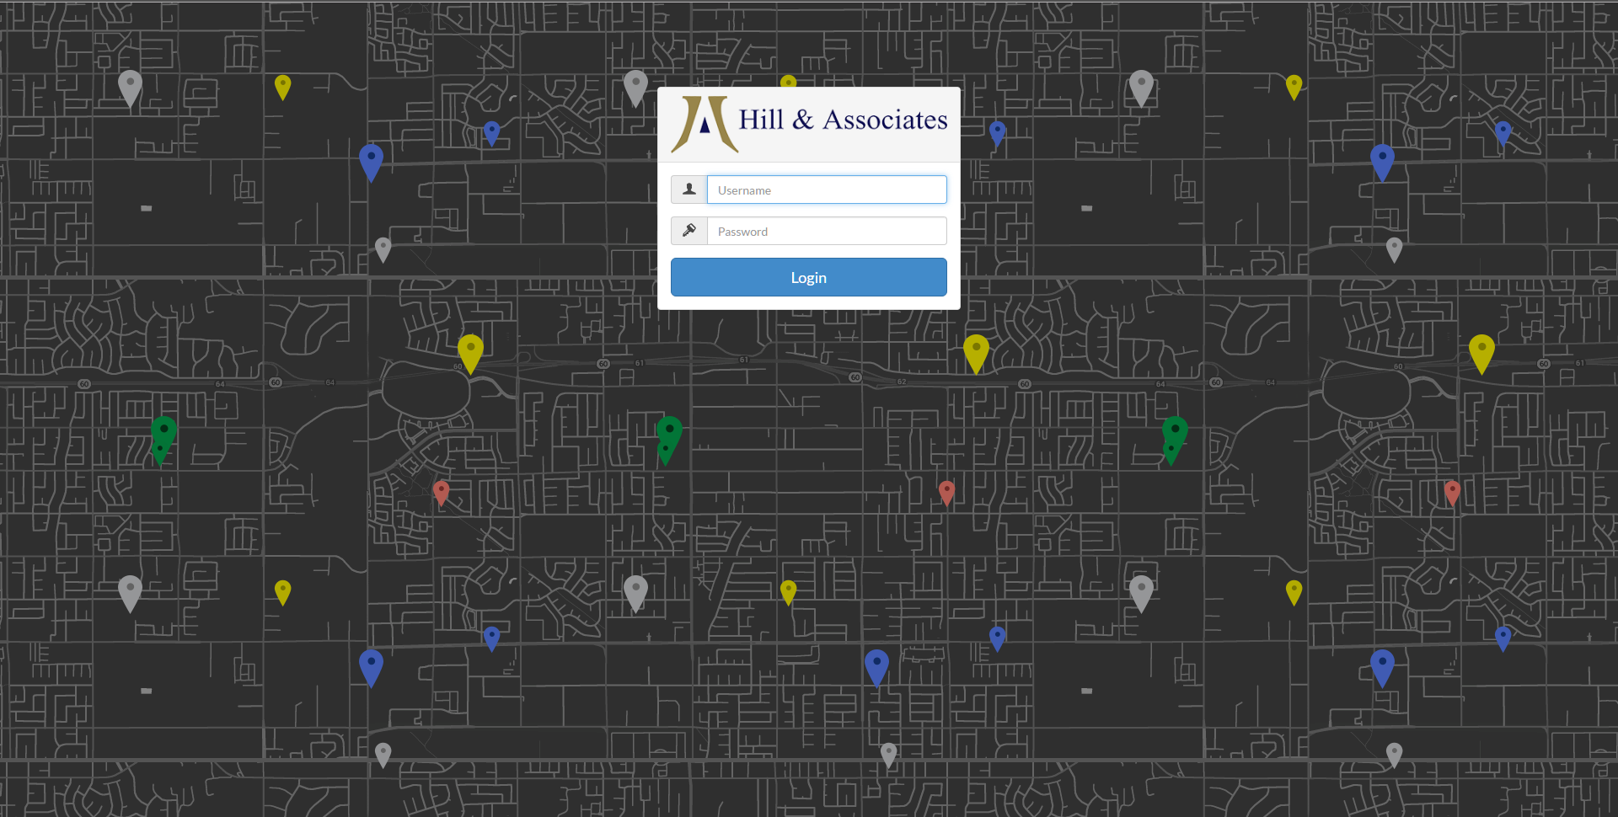

**MENU**

There are 4 types of menu in this web:

1. Secondary Menu
2. Top Menu
3. After Login Menu
4. Bottom Menu



Menus can be controlled by accessing “Menu” on the left panel of CMS.

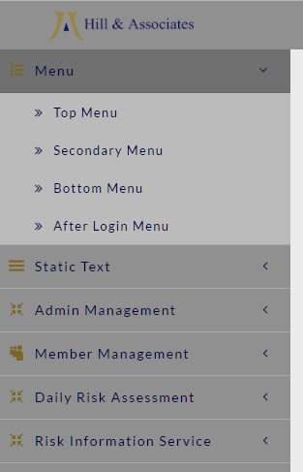

For example, click “Top Menu” to change top menu.

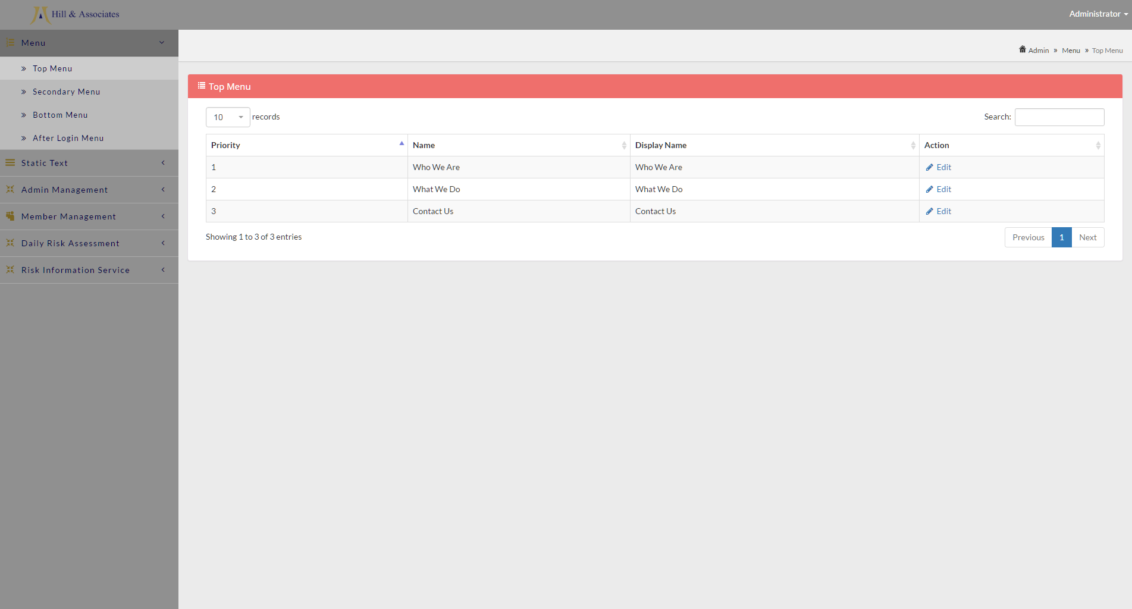

Information displayed consists of:

1. Priority

<<menunjukkan urutan tampilan menu>>

1. Name

Original name of the menu.

1. Display Name

Menu name that displayed at website.

If you click “Edit”, you can change the priority and display name of a menu item.

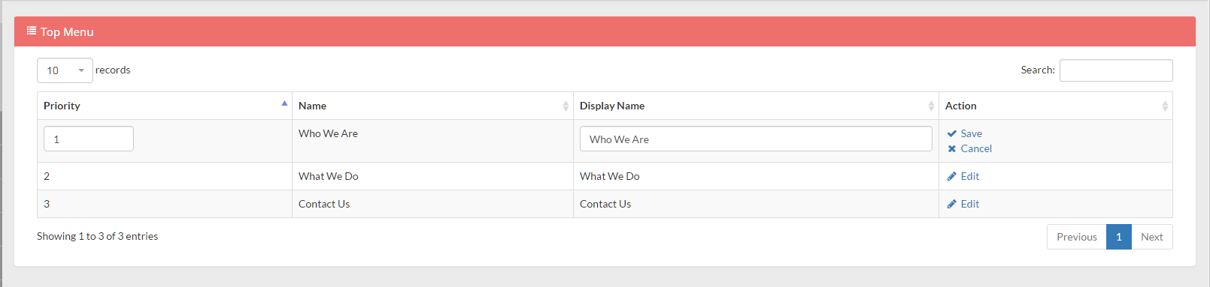

Click “Save” to save changes, or “Cancel” to discard changes.

<<ini berlaku juga untuk ketiga menu lainnya>>

**STATIC TEXT**

***Web Data***

Use this section to change website icon, header logo, footer logo, title, address, phone number, fax number, email, copyright, and social media account.

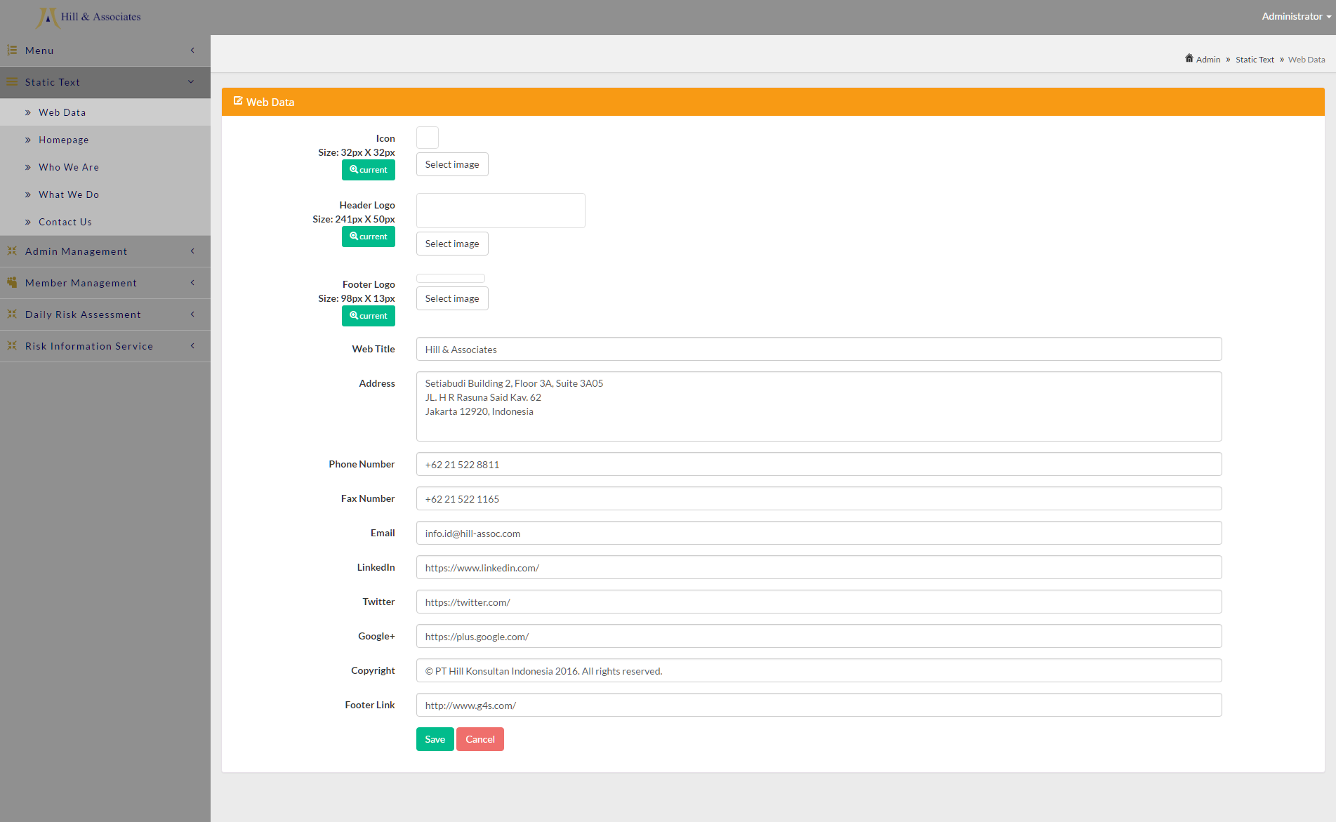

To change web icon, click “Select Image”. Then Select new image to replace current image. To view current image, click the green “Current” button under “Icon”. Click “Save” to save changes, or “Cancel” to discard changes.

***Homepage***

Use this section to change content of Homepage.

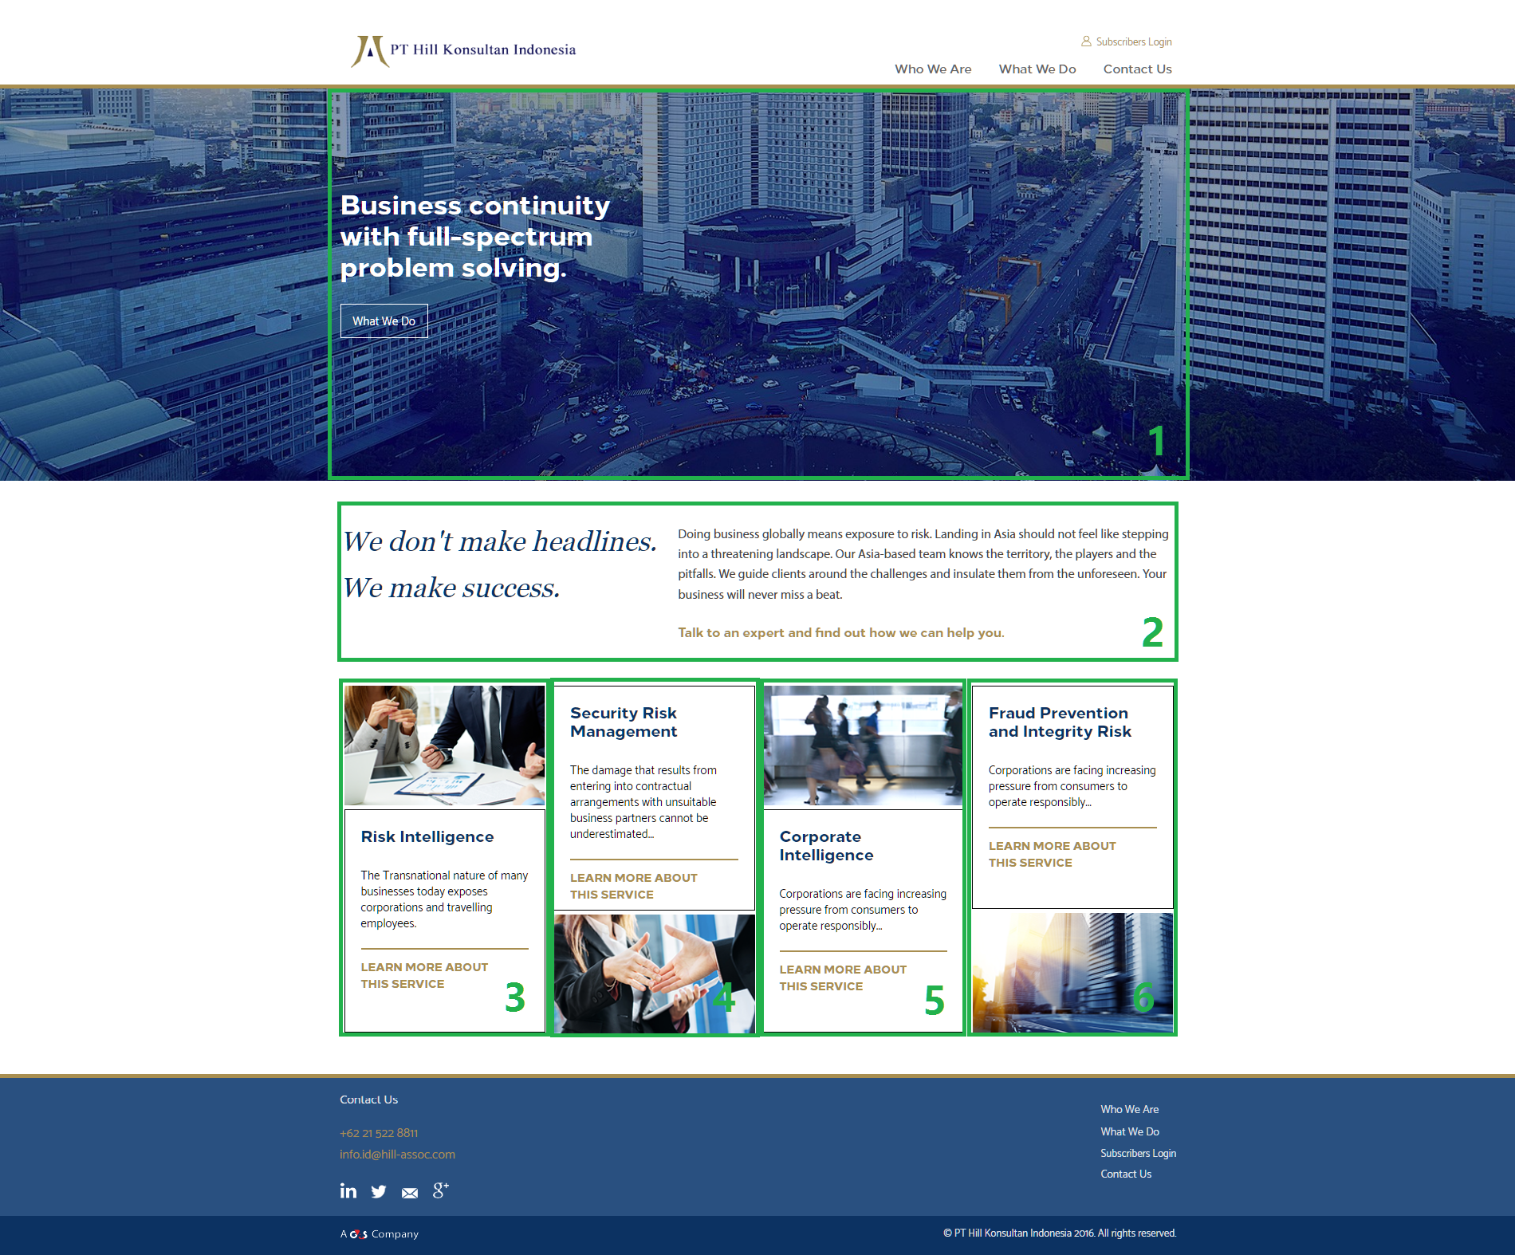

Homepage consists of 6 section:

1. Banner
2. Section 1
3. Section 2 Box 1
4. Section 2 Box 2
5. Section 2 Box 3
6. Section 2 Box 4

Each section can be edited in CMS.

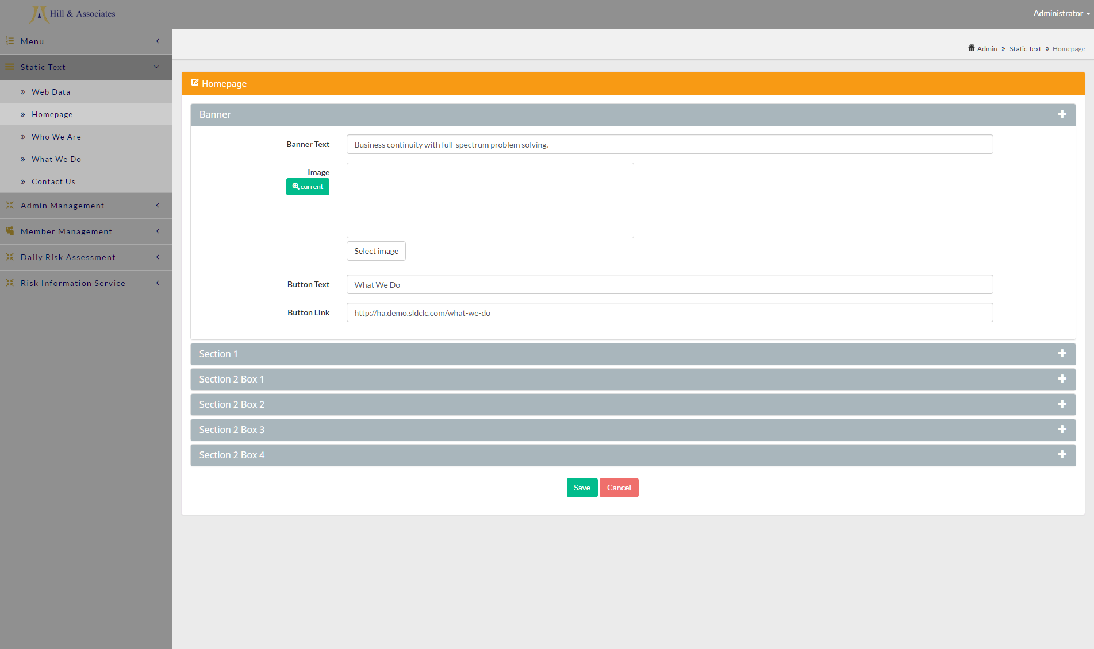

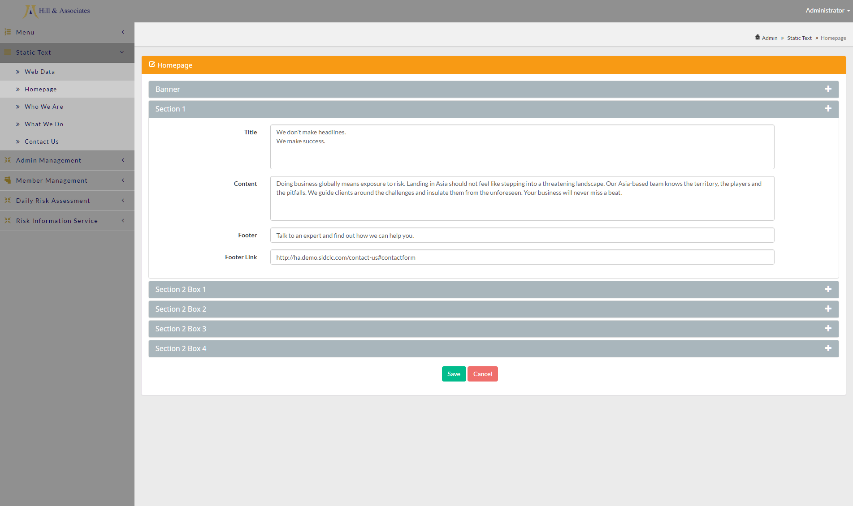

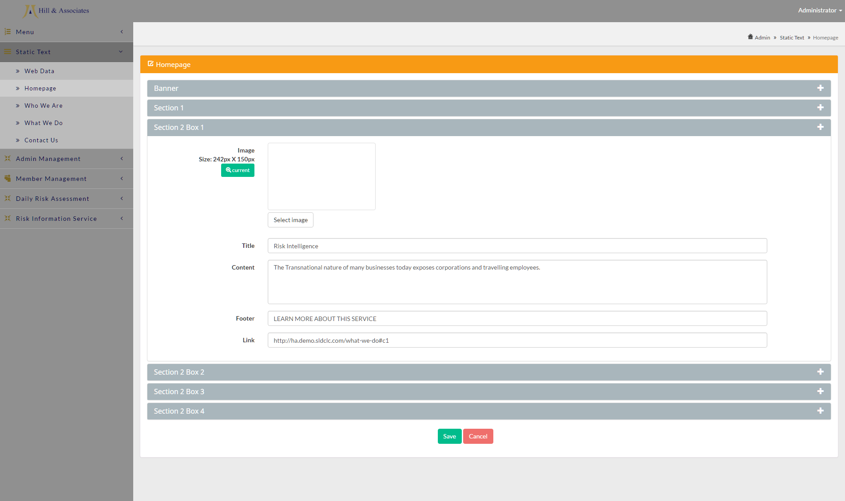

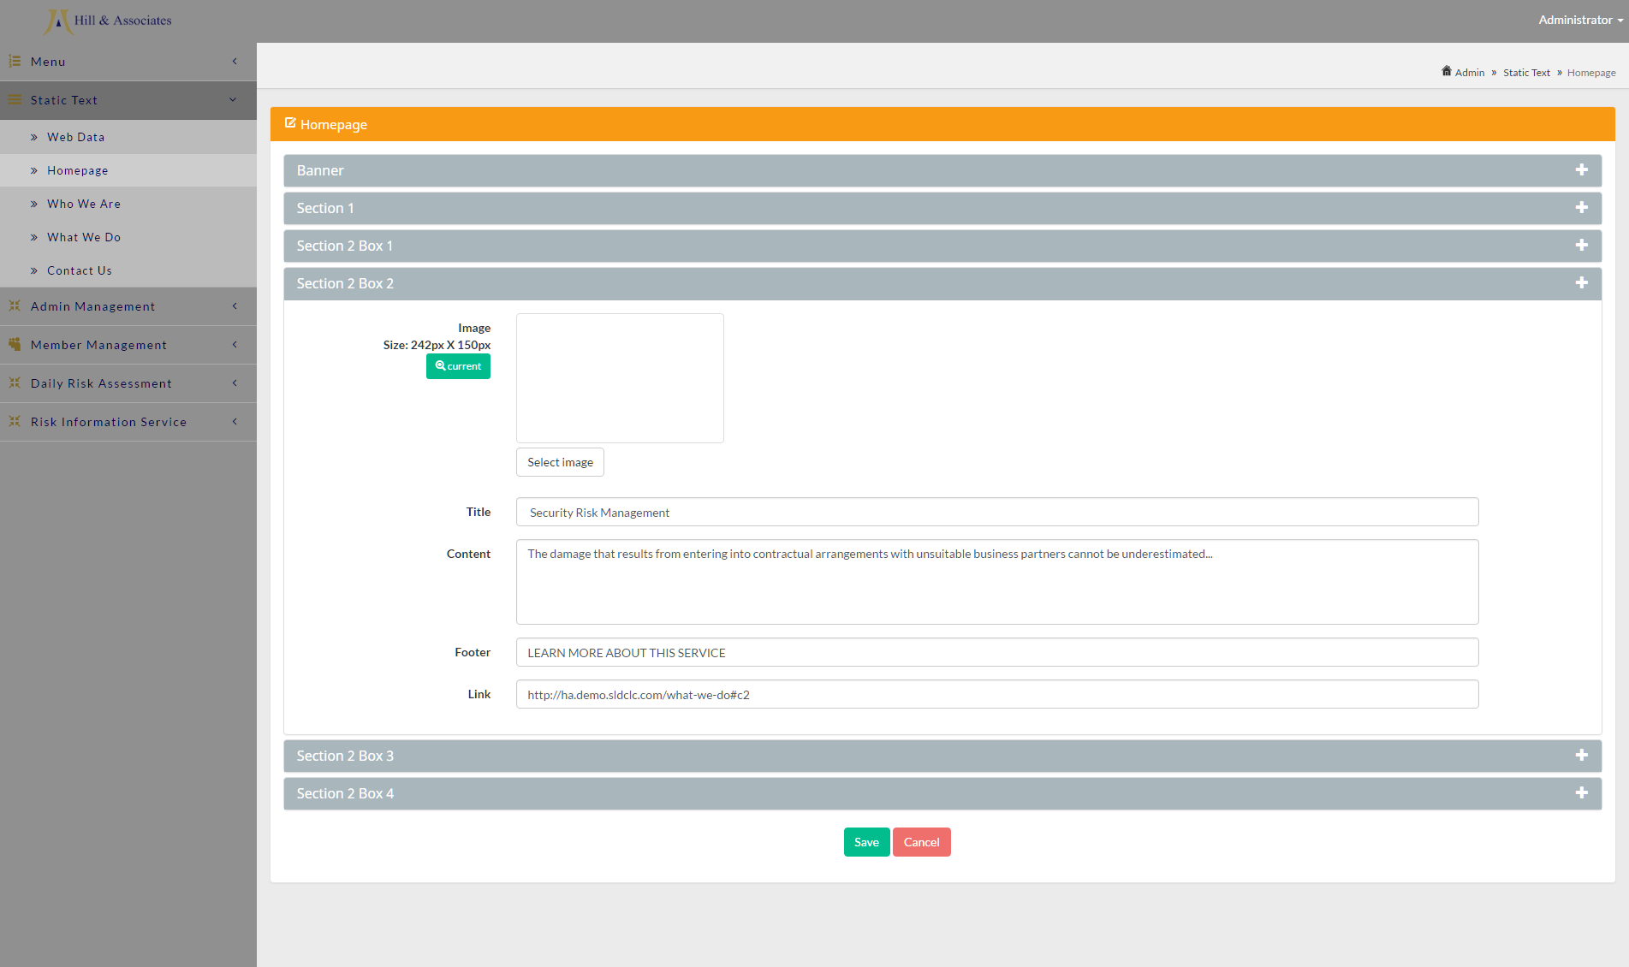

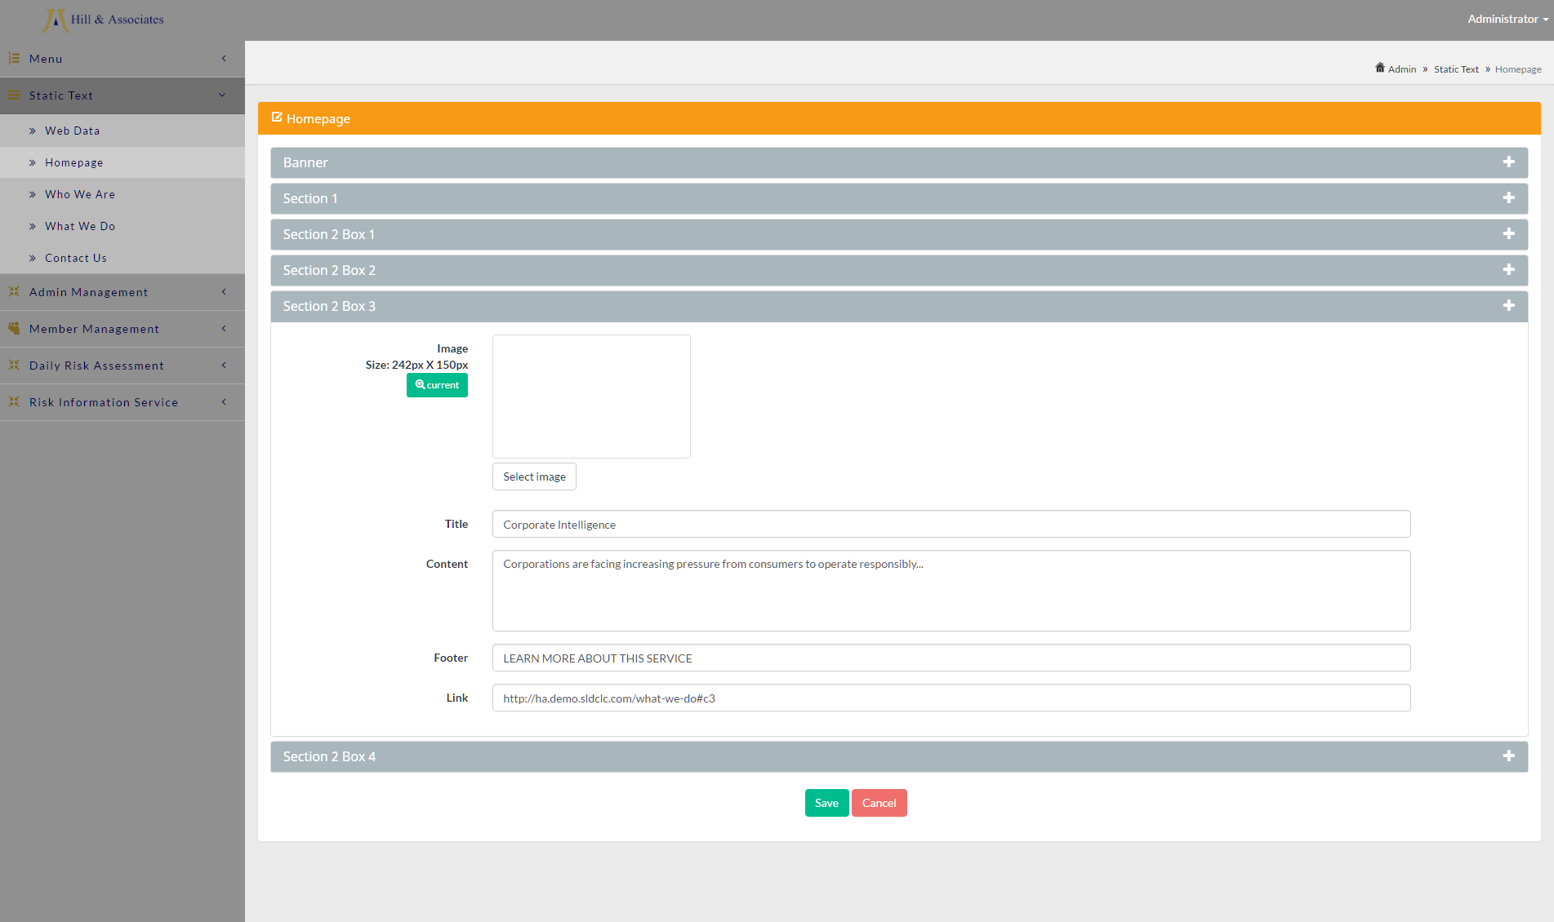

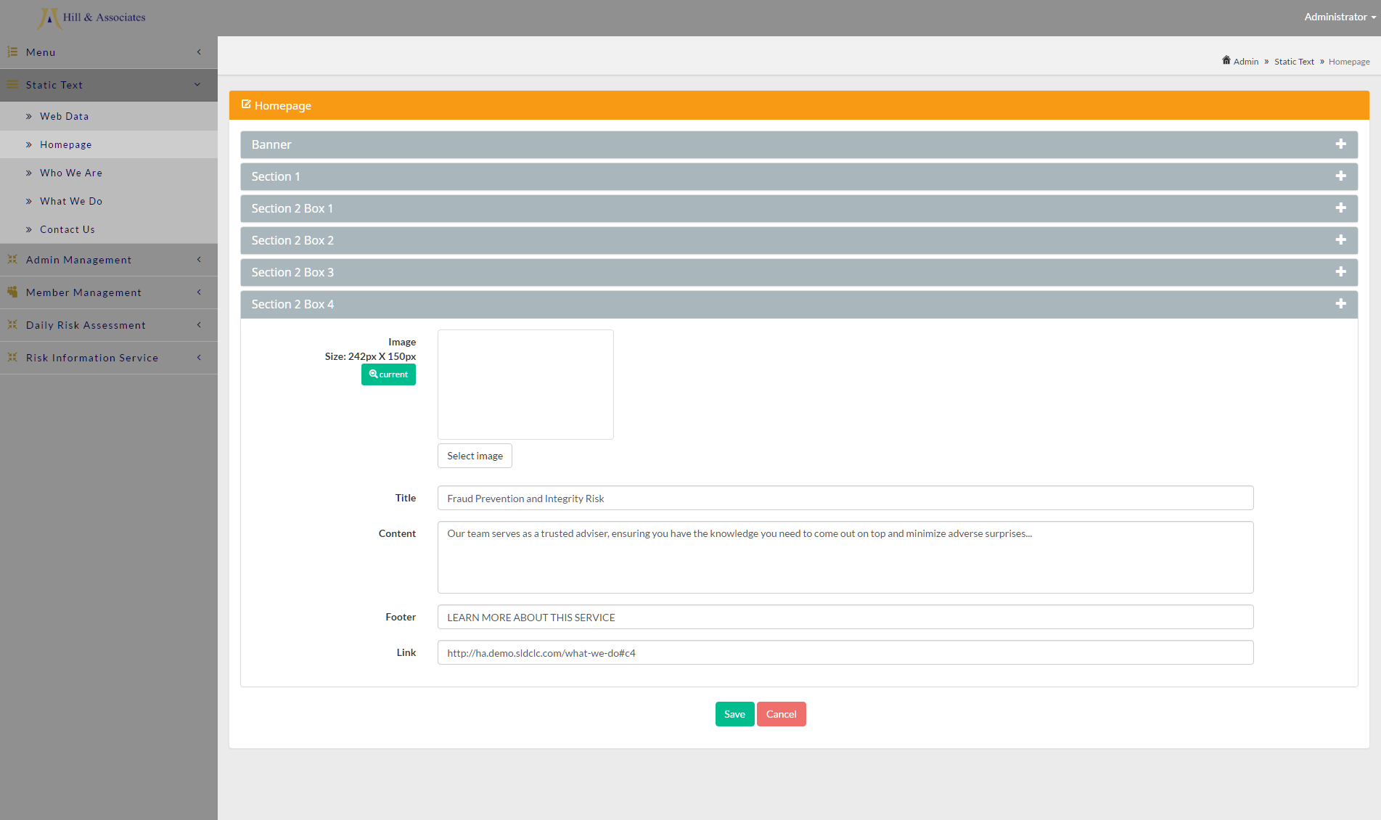

Click “Save” to save changes, or “Cancel” to discard changes.

***Who We Are***

Use this section to change content of Who We Are page.

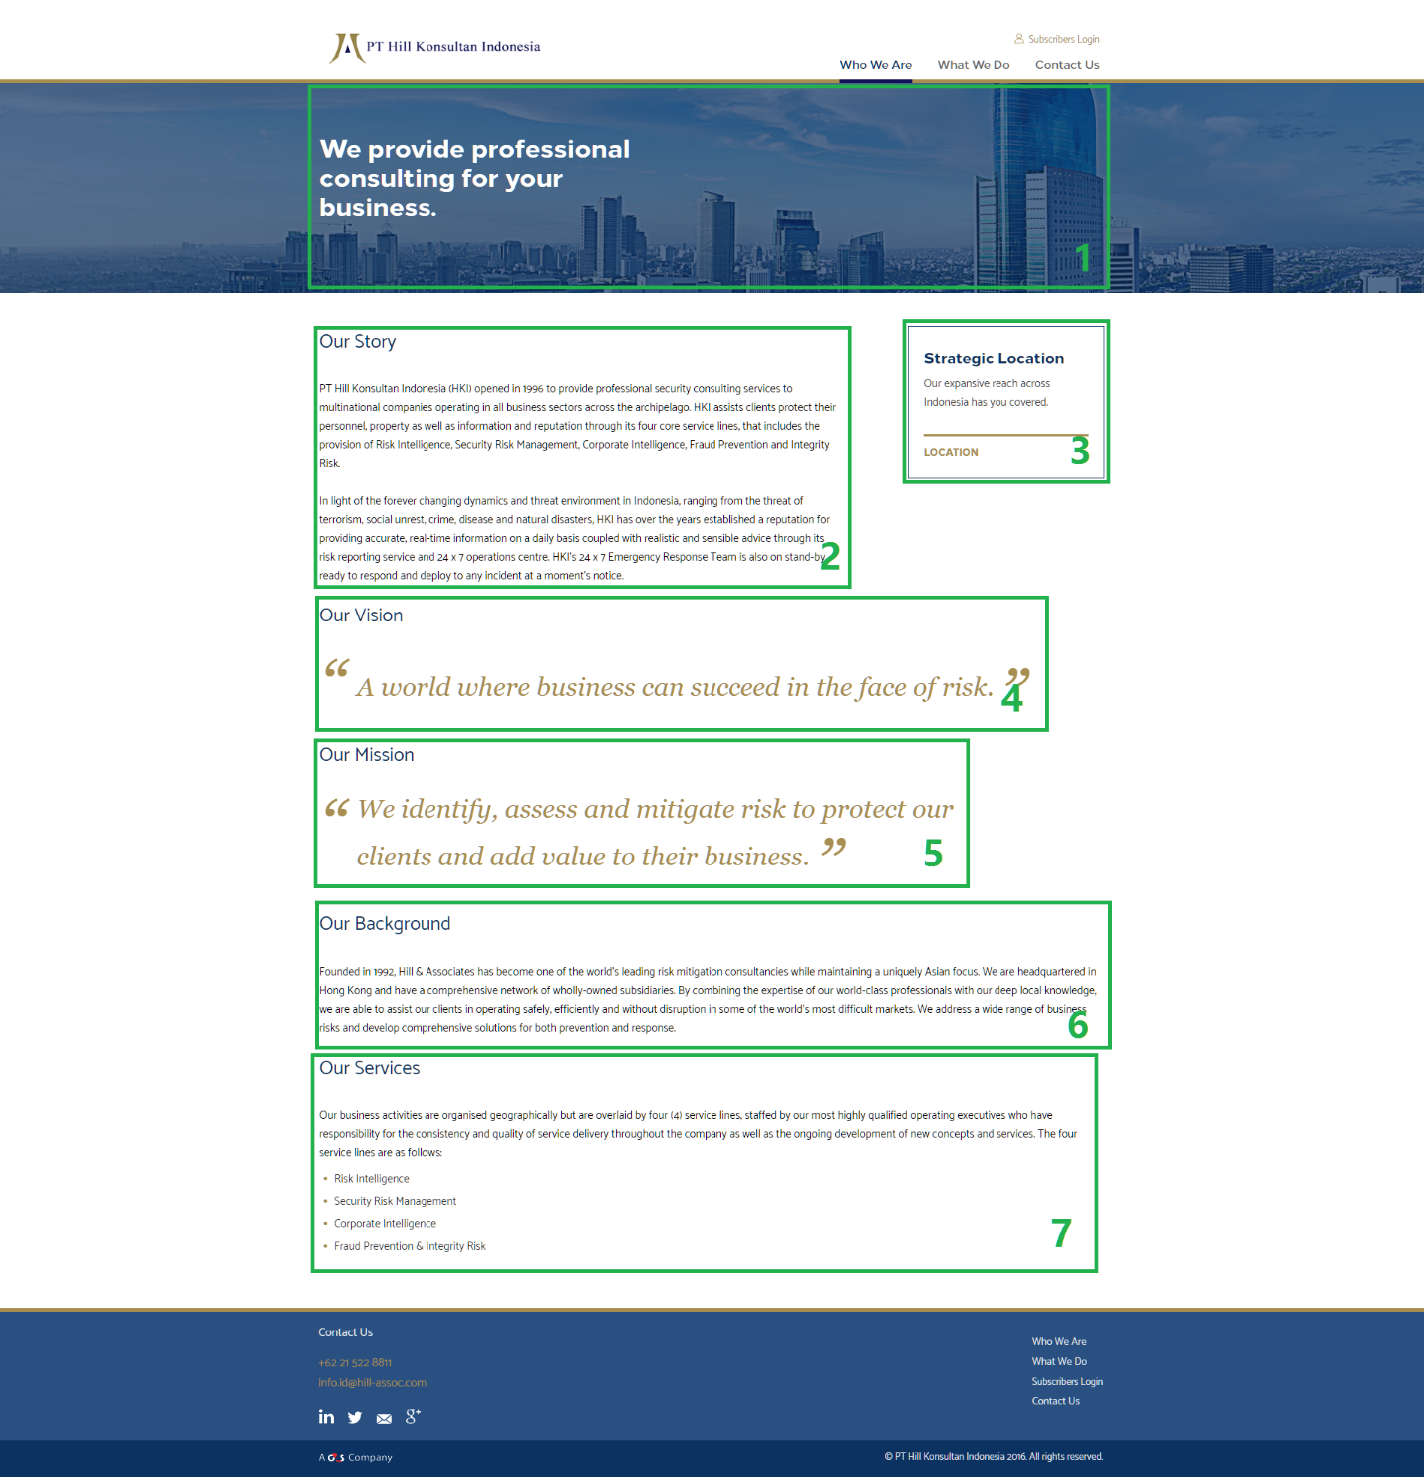

Homepage consists of 7 section:

1. Banner
2. Story
3. Box
4. Vision
5. Mission
6. Background
7. Services

Each section can be edited in CMS.

Click “Save” to save changes, or “Cancel” to discard changes.